5.40: Differentiating Eq. (5.10) with respect to time gives the acceleration
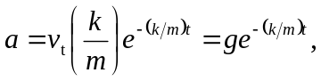
where Eq. (5.9), 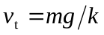 has been used.
Integrating Eq. (5.10) with respect to time with 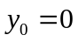 gives
